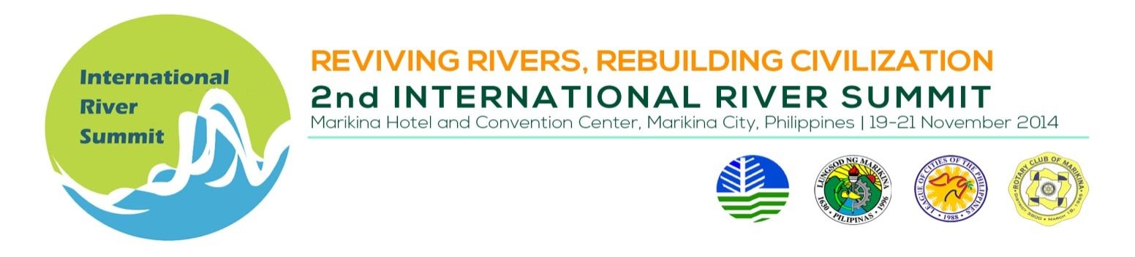
INDICATIVE PROGAMME

Thematic Session 3 : Research and development and extension on river studies

Venue : Session Rm.02, 2nd flr Convention Center

Date/Time : November 19, 2014, 1:30 – 5:00 PM

Session Chair : Ms. Julie Borje, Training Directress, Marikina City Center for
Excellence
Session Co-Chair : Dr. Donna Paz Reyes, Executive Director, Miriam College
Environmental Science Institute (ESI)

TIME | TOPIC | SPEAKER
 | SESSION INTRODUCTION | Ms. Julie Borje
 | Research for Policy Development: Institutionalizing Pollution Release and Transfer Register (PRTR) in the Philippines | Abigail Lois Aguilar  Toxics Campaigner,  Greenpeace Philippines
 | Water quality analysis and modeling fish diversity in Godavari Basin, Andhra Pradesh, India | Dr. Ajey K. Pathak, Senior Scientist, National Bureau of Fish Genetic Resources, India
 | BREAK
 | The Save Maningning Project: A Case Study on Youth Initiative in River Rehabilitation | Mr. John Tobit E. Cruz,  President and Co-founder, Angat Kabataan, Philippines
 | Bioremediation in Marilao-Meycauayan-Obado River System | Mr. Edgar A. Maranan, Chairman, Greenvironment
 | Marikina River Institute: A learning model | Dr. Donna Paz Reyes  Executive Director, Miriam College Environmental Science Institute, Philippines

